M.Abdullah.Mahmood
BCS-3B
22F-3289
To : sir saqib ameer
DS lab 12
Task 1 A:
#include<iostream>
using namespace std;

int deleteFromQueue(int& deletion, int size = 20) {
int choice;
cout << "do you want to delete from queue ? (0=n \ 1=y) \n";
cin >> choice;
if (choice == 0) {
return deletion;
}
else {
return (++deletion);
}
}

void makePriority(pair<int, int>* p, int size = 20) {
// Bubble sort
for (int i = 0; i < size; ++i) {
for (int j = i + 1; j < size; ++j) {
if (p[i].first < p[j].first) {
swap(p[i], p[j]);
}
}
}
}

void insertData(pair<int, int>* q,int &insertions, int size = 20) {
int amount = -1;
int token = -1;

for (int i = 0; i < size; ++i , ++insertions) {
cout << "Enter the token num : ";
cin >> token;
cout << "Enter the amount : ";
cin >> amount;

if (token == 0)
break;
q[i] = make_pair(token, amount);
}
makePriority(q);
}

void makeDeletions(int& del , int insertions ) {
if (del >= insertions) {
cout << "queue is already empty \n";
}
else {
bool flag = true;
while (flag) {
deleteFromQueue(del);
cout << "do you want to delete more from queue ? \n";
cin >> flag;
}
}
return;
}

int main() {

int deletions = 0;
int insertions = 0;

// first = token , second = bill
pair<int, int> que[20];
insertData(que,insertions);

// Print the sorted pairs
cout << "Sorted pairs based on token number:\n";
for (int i = 0; i< insertions; ++i) {
cout << "Pair " << i + 1 << ": (" << que[i].first << ", " << que[i].second << ")\n";
}

//to delete from queue
makeDeletions(deletions,insertions);

// Print the sorted pairs
cout << "Sorted pairs based on token number:\n";
for (deletions; deletions < insertions; ++deletions) {
cout << "Pair " << deletions + 1 << ": (" << que[deletions].first << ", " << que[deletions].second << ")\n";
}

return 0;
}
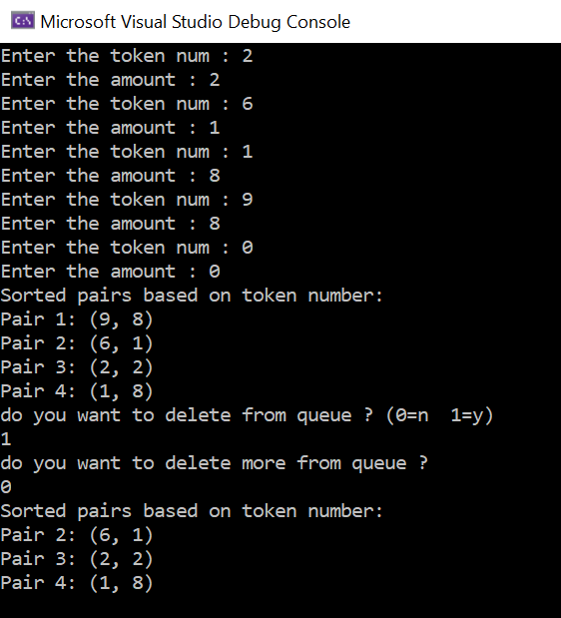
Task 2:
#include<iostream>
using namespace std;

class node {
public:
char data;
node* left;
node* right;

node(char data) {
this->data = data;
left = NULL;
right = NULL;
}

char btree[100] = { 0 };

void insertElement() {
int key;
char character;
cout << "Enter key: ";
cin >> key;
cout << "Enter character: ";
cin >> character;

if (key == 0) {
btree[key] = character;
}
else if (key > 0 && key < 100 && key % 2 != 0) {
int parentIndex = (key - 1) / 2;
if (btree[parentIndex] != 0) {
btree[key] = character;
}
else {
cout << "Parent does not exist, so child cannot be inserted.\n";
}
}
else {
cout << "Invalid key.\n";
}
}

void print() {
for (int i = 0; i < 100 && btree[i] != 0; ++i) {
cout << btree[i] << " ";
}
cout << endl;
}
};

int main() {
node* tree = new node('1'); // Initialize the root node
char ch = '1';
while (ch != '0') {
tree->insertElement();
cout << "Do you want to enter another element? (0 to exit): ";
cin >> ch;
}

cout << "Binary Tree: ";
tree->print();

return 0;
}
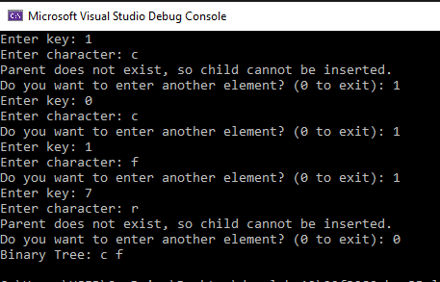
Task 3:
#include<iostream>
#include<queue>
using namespace std;

struct node {
int time;
string plate;
node* left;
node* right;

node(int time, const string& plate) : time(time), plate(plate), left(nullptr), right(nullptr) {}
node() : time(-1), plate(""), left(nullptr), right(nullptr) {}
};

void inorder(node* root) {
if (!root)
return;
inorder(root->left);
cout << root->time << " " << root->plate << endl;
inorder(root->right);
}

void bstmaking(node*& root, int time, string plate) {
node* newnode;
node* cur;

newnode = new node(time, plate);
if (root == nullptr) {
root = newnode;
}
else {
cur = root;
while (cur) {
if (time > cur->time) {
if (cur->right)
cur = cur->right;
else
{
cur->right = newnode;
break;
}
}
else if (time < cur->time) {
if (cur->left)
cur = cur->left;
else {
cur->left = newnode;
break;
}
}
else {
break;
}
}
}
}

node* maxfromleft(node* root) {
node* temp = root;
while (temp && temp->right) {
temp = temp->right;
}
return temp;
}

node* deletion(node*& root, int time) {
//base case
if (root == nullptr)
{
cout << "node not found in tree \n";
return root;
}

//root node < value
if (time > root->time)
{
root->right = deletion(root->right, time);
}
//root node > value
else if (time < root->time)
{
root->left = deletion(root->left, time);
}
//deletion at root node = value
else {

//no child
if (root->left == NULL && root->right == nullptr)
{
delete root;
return nullptr;
}
//one child
if (root->left && !root->right) {
node* temp = root->left;
delete root;
return temp;
}
if (!root->left && root->right) {
node* temp = root->right;
delete root;
return temp;
}
//two child and root
if (root->left && root->right) {
int value = maxfromleft(root->left)->time;
root->time = value;
root->left = deletion(root->left, value);
}
}

return root;
}

void convert(int arr[], int& size,node* root) {
if (!root)
return;
convert(arr,size, root->left);
arr[size++] = root->time;
convert(arr, size, root->right);
}

void levelordertraversal(node* root) {
queue<node*>q;
q.push(root);
q.push(nullptr);

while (!q.empty()) {
node* temp = q.front();
q.pop();

if (temp == nullptr) {
cout << endl;

if (!q.empty())
q.push(nullptr);
}
else {
cout << temp->time ;
if (temp->left) // left childs insertion
q.push(temp->left);

if (temp->right) //right childs insertion
q.push(temp->right);
}
}

return;
}

void heapify(int arr[], int size, int index) {
int largest = index;
int left = 2 * index;
int right = 2 * index + 1;

if (left <= size && arr[largest] < arr[left])
largest = left;
if (right <= size && arr[largest] < arr[right])
largest = right;

if (largest != index)
{
swap(arr[largest], arr[index]);
heapify(arr, size, largest);
}

return;
}

void heapsort(int arr[], int size, int index = 1) {
int temp = size;
while (size > 1) {
swap(arr[size], arr[1]);
size-- ;
heapify(arr, size, 1);
}
}

int main() {
node* tree1 = nullptr;
node* heaptree = nullptr;
int size = 1;
int arr[20] = {};
// making of bst
bool flag = true;
while (flag) {
int time;
cout << "enter time: \n";
cin >> time;
string plate;
cout << "enter plate: \n";
cin >> plate;
bstmaking(tree1, time, plate);
cout << "do you want to continue? (1-0): ";
cin >> flag;
}

// before deletion bst
cout << "traversal: \n";
levelordertraversal(tree1);

// after deletion bst
cout << "deletion of 10 \n";
deletion(tree1, 10);
cout << endl;
cout << "traversal after deletion: \n";
levelordertraversal(tree1);
cout << endl;

cout << "conversion to array : ";
convert(arr, size,tree1 );
for (int i = 1; i < size; ++i) {
cout << arr[i] << " ";
} cout << endl;

int n = size - 1;

for (int i = n/2; i > 0; --i) {
heapify(arr, size, i);
}

heapsort(arr, size);
cout << "after heap sort : \n";
for (int i = 1; i <= size; ++i) {
cout << arr[i] << " ";
} cout << endl;

return 0;
}

